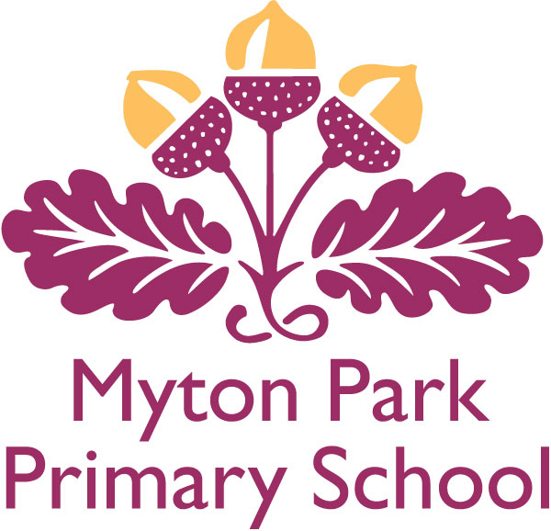

British Values Policy

CREATED/REVISED: | Autumn Term 2017
REVIEW DATE: | Spring Term 2019
APPROVED BY GOVERNING BODY: | School Improvement 8th November 2017

Myton Park Primary School
Being the Best Person You Can
(British Values Policy)
1. Definition
British Values- simply put, are a set of important values to live by.

2. Stockton’s shared definition of British Values
In our inclusive school, we value, seek to understand, and identify potential in everyone. We encourage everyone in our school community to engage in the life of the school and wider community.
We promote values which include: British democracy; the rule of law; individual liberty; respect and tolerance of different faiths and beliefs (and no faith) - alongside an appreciation and celebration of difference and diversity (reflecting all protected characteristics and social class). We promote rights and accept that with rights come responsibility.
Valuing our cultural heritage, we explore our local, regional and national heritage and British History, both positive and negative- learning from history and taking pride in positive contributions made.

3. Inspectors will look for:
We actively promote the fundamental British Values of democracy, the rule of law, individual linearity* and mutual respect and tolerance of those with different faith and beliefs
*thinking about or feelings for the consequences of actions, thinking ahead- five or ten steps down the road, the effect individuals actions have on others, seeing yourself as part of the problem/solution.

4. Our ethos and community
Our ethos, strap line and curriculum statement underpin everything we do. They determine how we treat each other and the values we wish to present to our immediate and wider community. They guide our curriculum and the standards we set for ourselves.

At Myton Park we aspire to have a true community feel where all pupils, parents, staff, governors, volunteers and other community members work together to ensure we all reach our true potential.

We resolutely peruse and endeavour to set the very highest standards in all areas, which means-we must all commit to set the highest standards for ourselves. We envision a school where relationships are positive, expectations are high and we all have the self-belief and drive to accomplish our aspirations, within a learning environment that aims to meet the needs of all stakeholders.

To achieve this, we must all- children, parents, staff, governors, volunteers and community members- approach all situations with a positive ethos. We expect mutual respect and commitment to the following protocol.
- We are here for each other and the children in our care
- We demonstrate good manners at all times
- We talk to each other
- We listen to each other
- We make time for each other
- We meet each other
- We inform each other
- We are honest with each other
- We support each other
- We respect each other
- We celebrate and share our different strengths
Myton Park Primary School
‘Nurturing skills for life’

Our curriculum aims for high standards whilst providing valuable and memorable
opportunities for all children to learn, grow and develop the skills, knowledge and
understanding relevant to their needs now and their future lives. It promotes a
willingness to question and explore, widen their horizons, develop their aspirations
and instil self-belief.

5. Our Society
Our ethos, strap line and curriculum statement underpin everything we do and guide the society we want to create in our school. We link to home school agreement, teachers standards, prevent, anti-bullying, substance misuses, web site, minority groups and safe guarding to them.

Our children
Characteristic of children we want to develop
The children and staff were all involved in identify a set of characteristics we felt the children and staff at Myton Park should aspire to.
Remember it takes all of us doing the right thing to make Myton Park Primary a happy community we feel proud to belong to.
Caring Generous
Determined Forgiving
Respectful Responsible
Polite Enthusiastic
Cheerful Smart
Honest Resilient
Friendly Conscientious

We also believe these articles form the UNICEF have a particular resonance with our children.

Article 3 The best interests of the child must be a top priority.

Article 12 Every child has the right to say what they think in all matters affecting them and to have their views taken seriously.

Article 13 Every child must be free to say what they think and seek and receive information of any kind as long as it is within the law.

Article 14 Every child has the right to thin and believe what they want and also to practice their religion, as long as they are not stopping other people from enjoying their rights. Governments must respect the rights of parents to give their children guidance about this right.

Article 29 Education must develop every child’s personality, talents and abilities to the full. It must encourage the child’s respect for human rights, as well as respect for their parents, their own and other cultures, and the environment.

Article 31 Every child has the right to relax, play and join in a wide range of cultural and artistic activities.

6. Our Role
Our values and attitudes help prepare children for life in modern Britain.

SMSC
safe guarding
clubs
SENd
enrichment days and weeks
assemblies
links with the wider community,
sports
healthy lifestyle
buddies
school council
friendship week
learning behaviours

Our curriculum prepares children for life in modern Britain. We recognise that some of the issues taught will at times be challenging but appropriate to the needs and age of our children.

The list below is not intended to be exhaustive but gives an idea of how British Values is a part of our whole curriculum

History- important events and famous people
PHSCE- values, behaviour, life skills
RE-faiths, morals, understanding
Music- national music and identify
Art and DT- British art, artists and designers;
Geography- world awareness week, understanding and knowledge of other countries, human impact on the environment
Science- healthy eating, active life style, health and safety
SMSC- the style of teaching and expectations and the values we constantly reinforce
English- British literature
Maths- British systems, monetary values
ICT- internet safety
PE- fitness, life style, sportsmanship

In the class
Around school
In the playground We see our role contributing to these key areas
At home
In the immediate community
The wider community

September 17

