21
Calculations Policy

CREATED/REVISED BY: | Mrs Lee
NEXT REVIEW DATE: | Summer Term 2020
APPROVED BY GOVERNING BODY: | School Improvement 20.02.18

The Aim of this policy is to make sure our
children can independently and successfully apply their knowledge and
understanding of calculations to mathematical problems
and challenges across the curriculum.

When planning, teachers should consider the following;
- The children should always be taught a method using concrete apparatus as a support so they can understand what they are doing.
- Children should be expected to show their working out or jottings while they are learning a new method.
- Teaching should follow the White Rose Scheme of learning across school to avoid contradiction and confusion.
- Teachers should look at the methods above and below their year group to develop variation and differentiation.
- Methods should be taught when the children are ready for them not just because they are in a
certain year group.
- The method should be consistently developed until children are independently secure in its use, then revisited in mental starters to avoid the skill being lost.
- Effective questioning should accompany teaching of the method to ensure children’s understanding of what they are doing and why.
- One number to a square must be insisted on for place value. This will also help them later when working with decimals.

When using any calculations, the = sign must be used in a variety of positions. This helps the children to understand this means equal, rather than the question is, therefore the answer is.
For example:
3 + 5 = 8
8 = 3 + 5
Missing numbers must also be used to develop reasoning skills.
8 = + 5

Addition-
Key language which should be used: sum, total, parts and wholes, plus, add, altogether, more than, ‘is equal to’ ‘is the same as’
Concrete | Pictorial | Abstract
Combining two parts to make a whole (use a variety of resources e.g. eggs, shells, teddy bears etc)  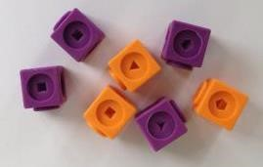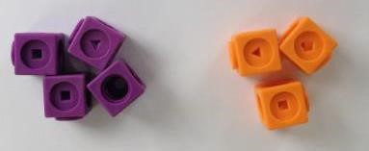 | 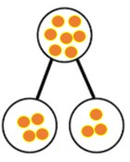 | 4 + 3 = 7 (four is a part, 3 is a part and the whole is seven)  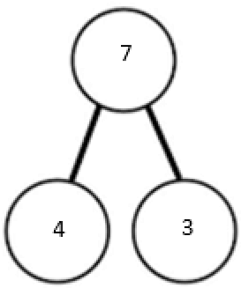
Counting on using number lines by using cubes, bead strings or Numicon  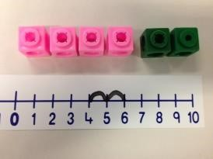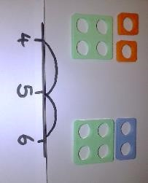 | A bar model which encourages the children to count on  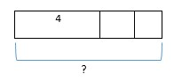 | The abstract number line:  What is 2 more than 4? What is the sum of 4 and 4? What’s the total of 4 and 2? 4 + 2  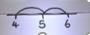
Regrouping to make 10 by using ten frames and counters/cubes, bead strings or using Numicon: 6 + 5  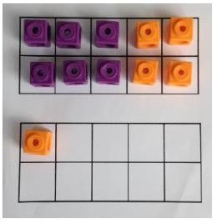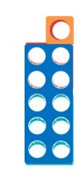 | Children to draw the ten frame and counters/cubes  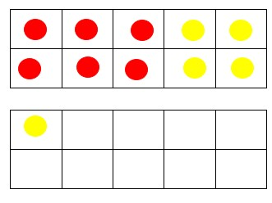 | Children to develop an understanding of equality e.g. 6 + □ = 11 and  11 – 6 + □  6 + 5 = 5 + □ 6 + 5 = □ + 4

TU + U using base 10. Continue to develop understanding of partitioning and place value 41 + 8  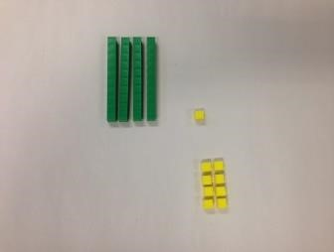 | Children to represent the concrete using a particular symbol e.g. lines for tens and dot/crosses for ones. Part whole models showing tens and ones  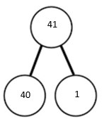  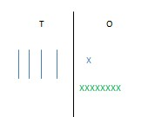 | 41 + 8  1 + 8 = 9  40 + 9 = 49  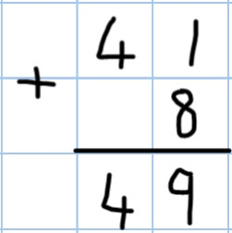
TU + TU using base 10. Continue to develop understanding of partitioning and place value and use this to support addition. Begin with no exchanging. 36 + 25  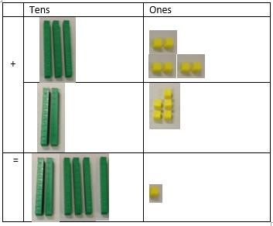 | This could be done one of two ways:  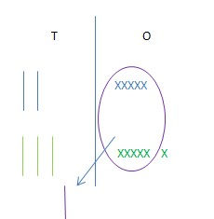  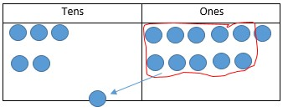 | Looking for ways to make 10.  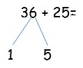  Formal method:  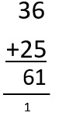 | 30 + 20 = 50  5 + 5 = 10  50 + 10 + 1 = 61

Use of place value counters to add HTU + TU, HTU + HTU etc. once the children have had practice with this, they should be able to apply it to larger numbers and the abstract.  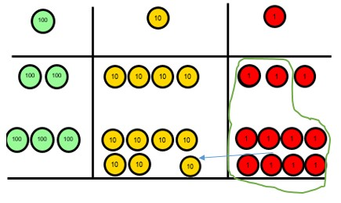 |  | Chidren to represent the counters e.g. like the image below.  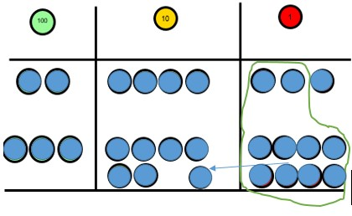  If the children are completing a word problem, draw a bar model to represent what it’s asking them to do  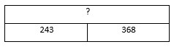 |  | 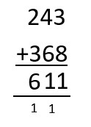
Varied Fluency, different ways to ask children to solve 21+34:
 | Sam saved £21 one week and
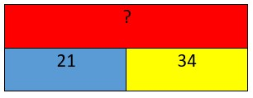 | £34 another. How much did he save in total?  21+34=55. Prove it! (reasoning but the children need to be fluent in representing this) |  | 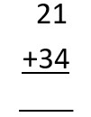  21 + 34 =  = 21 + 34  What’s the sum of twenty one and thirty four? |  | 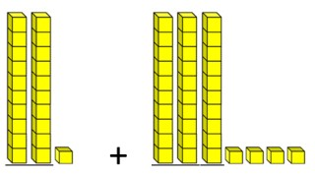  Use missing number problems to develop reasoning skills:  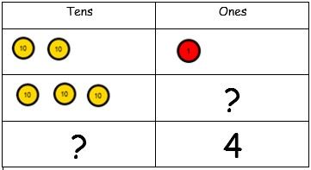

By the end of Year 1 - the children should know, by instant recall, their number bonds to 10. They should be able to translate this to tens numbers to at least 100.
- By the end of Year 2 – the children should be able to recall how a number less than 10 can be split into 5 and another number, or know how many less than 5 it is (This helps with mental arithmetic).

Subtraction-
Key language which should be used: take away, less than, the difference, subtract, minus, fewer, decrease, ‘7 take away 3, the difference is four’

Concrete | Pictorial | Abstract
Physically taking away and removing objects from a whole (use a variety of objects) rather than crossing out- children will physically remove the objects  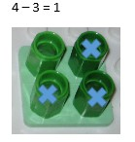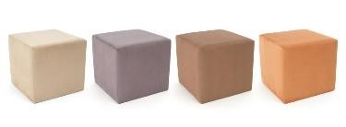 | Children to draw the concrete resources they are using and cross out.  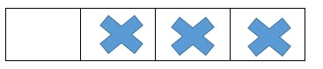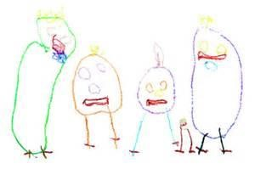  Use of the bar model: | 4- 3 =  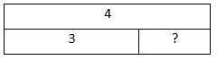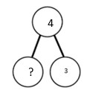  =  4  –  3
Counting back (using number lines or number tracks)  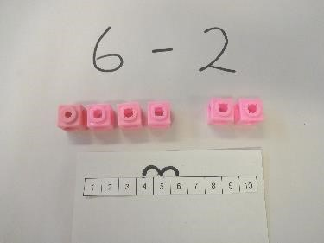 | Children to represent what they see pictorially e.g.  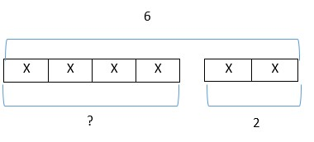 | 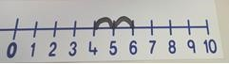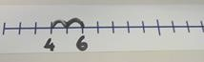

Finding the difference (using cubes, Numicon or Cuisenaire rods, other objects can also be used)  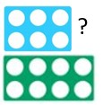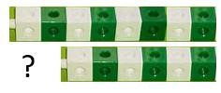 | Children to draw the cubes/other concrete objects which they have used  XXXXXXXX  XXXXXX  Use of the bar model  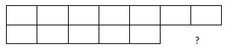 | Find the difference between 8 and 6.  - – 6, the difference is ?  Children to also explore why  - - 7 = 8 – 6 (the difference, of each digit, has changed by 1 do the difference is the same- this will help  when solving 10000-9987)
Making 10 (using Numicon or ten frames)  14 – 5  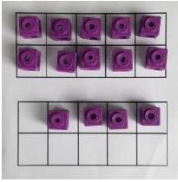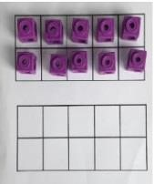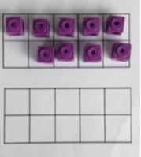  Children could also do this by subtracting a 5 from the 10.  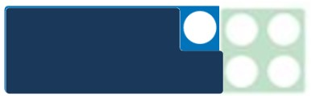 | Children to present the ten frame pictorially  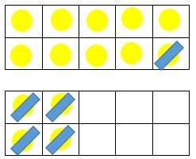 | 14 – 5 = 9 Children must continue to develop this until they see related facts e.g. 15 – 9 = 5  Children must represent their working out e.g.  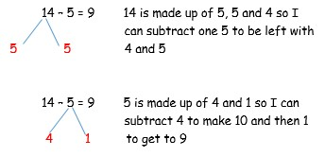
Column method (using base 10) 48-7  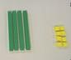 | 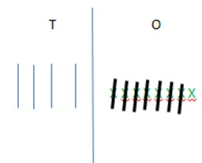 | 48 – 7 =  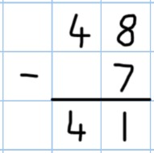

Column method (using base 10 and having to exchange) 45-26 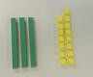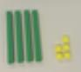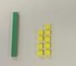  - Start by partitioning 45  - Exchange one ten for ten more ones  - Subtract the ones, then the tens. |  | Represent the base 10 pictorially  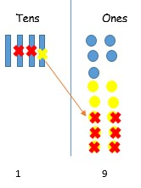 |  |  | It’s crucial that the children understand that when they have exchanged the 10 they still have 45. 45 = 30 + 15  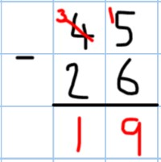
Column method (using place value 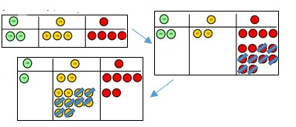counters) 234-88 |  | Once the children have had practice with the concrete, they should be able to apply it to any subtraction.  Like the other pictorial representations, children to represent the counters. |  |  | 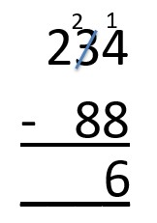
Varied Fluency, different ways to ask children to solve 391-186:
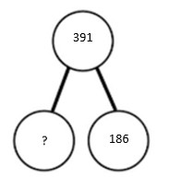  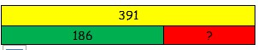 | Raj spent £391, Timmy spent £186. How much more did Raj spend?  I had 391 metres to run. After 186 I stopped. How many metres do I have left to run? |  | 391 – 186 |  | What’s the calculation? What’s the answer?
= 391 – 186
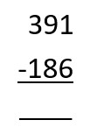

Find the difference between 391 and 186.

Subtract 186 from 391.

What is 186 less than 391?

Multiplication-
Key language which should be used: double, times, multiplied by, the product of, groups of, lots of, ‘is equal to’ ‘is the same as’
Concrete | Pictorial | Abstract
Repeated grouping/repeated addition  (does not have to be restricted to cubes)  3 x 4 or 3 lots of 4  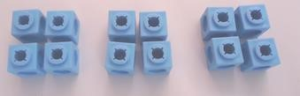 | Children to represent the practical resources in a picture e.g.  XX XX XX  XX XX XX  Use of a bar model for a more structured method  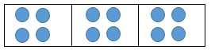 | - x 4  - + 4 + 4
Use number lines to show repeated groups- 3 x 4  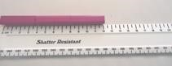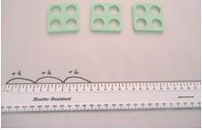 | Represent this pictorially alongside a number line e.g:  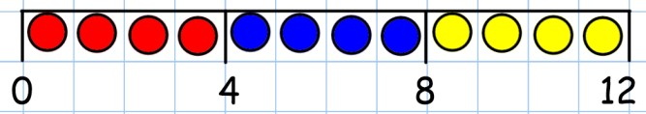 | Abstract number line  3 x 4 = 12  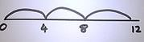
Use arrays to illustrate commutativity (counters and other objects can also be used)  2 x 5 = 5 x 2  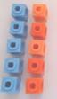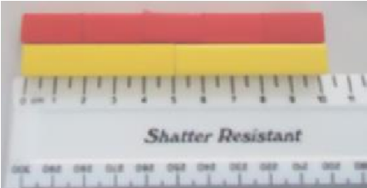 | Children to draw the arrays  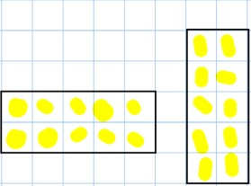 | Children to be able to use an array to write a range of calculations e.g.  2 x 5 = 10  5 x 2 = 10  2 + 2 + 2 + 2 + 2 = 10  5 + 5 =10

Partition to multiply (use Numicon, base  10, Cuisenaire rods)  4 x 15  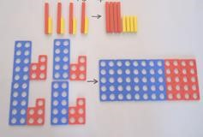 | Children to represent the concrete manipulatives in a picture e.g. base 10 can be represented like:  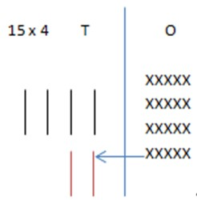 | Children to be encouraged to show the steps they have taken  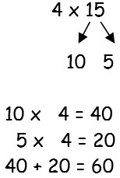  A number line can also be used  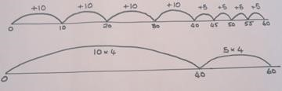
Formal column method with place value counters or base 10 (at the first stage- no exchanging) 3 x 23  Make 23, 3 times. See how many ones, then how many tens  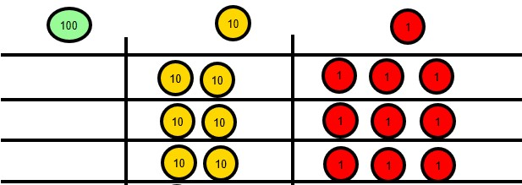 | Children to represent the counters in a pictorial way  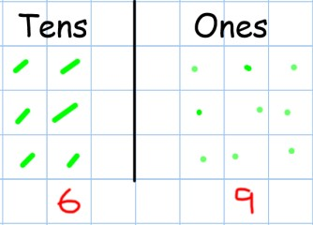 | Children to record what it is they are doing to show understanding  3 x 23 3 x 20 = 60  3 x 3 = 9  20 3 60 + 9= 69  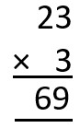
Formal column method with place value counters (children need this stage, initially, to understand how the column method works) | Children to represent the counters/base 10, pictorially e.g. the image below. | 6 x 23  6 x 3 = 18  6 x 20 = 120  120 + 18 = 138

6 x 23  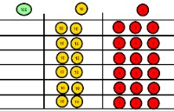  Step 1: get 6 lots of 23  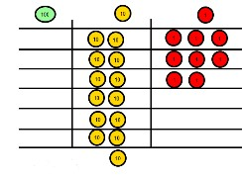  Step 2: 6 x 3 is 18. Can I make an exchange? Yes!  Ten ones for one ten….  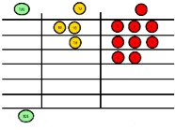  Step 3: 6 x 2 tens and my extra ten is 13 tens. Can I make an exchange? Yes! Ten  tens for one hundred…  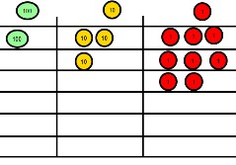  Step 4- what do I have I each column? |  | 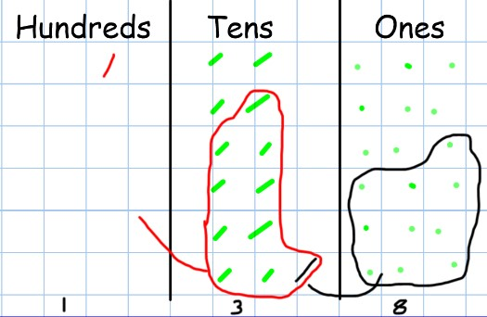 |  | The aim is to get to the formal method but the children need to understand how it works.  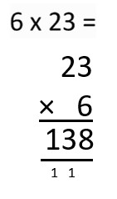
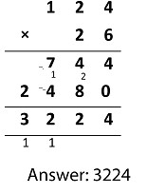
When children start to multiply 3d x 3d and 4d x 2d etc, they should be confident with the abstract:

To get 744 children have solved 6 x 124
To get 2480 they have solved 20 x 124

Children must then understand they must add the two sums together.

Varied Fluency, different ways to ask children to solve 6 x 23:
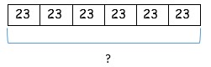  With the counters, prove that 6 x 23 = 138  Why is 6 x 23 = 32 x 6? | Mai had to swim 23 lengths, 6 times a week. How many lengths did she swim in one week?  Tom saved 23p three days a week. How much did he save in 2 weeks? |  | Find the product of 6 and  23  6 x 23 =  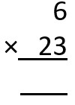  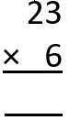  = 6 x 23 | What’s the calculation? What’s the answer?  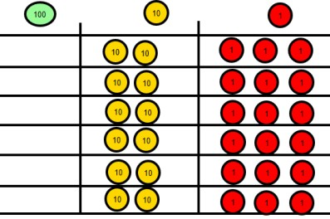

The children must understand each multiplication and division fact for each times table.
4 x 6 = 24
6 x 4 = 24
24 divided by 6 = 4
24 divided by 4 = 6

See below for minimum year group expectations:

End of year 1: 2, 5 and 10.
End of year 2: 2, 5 and 10
End of Year 3: 3, 4, 8 and 11
End of Year 4: 6, 7, 9, and 12

The children should be able to apply their knowledge to understand that they do not need to learn each table separately. They must be able to see that the inverse rule means they already know many of the tables.

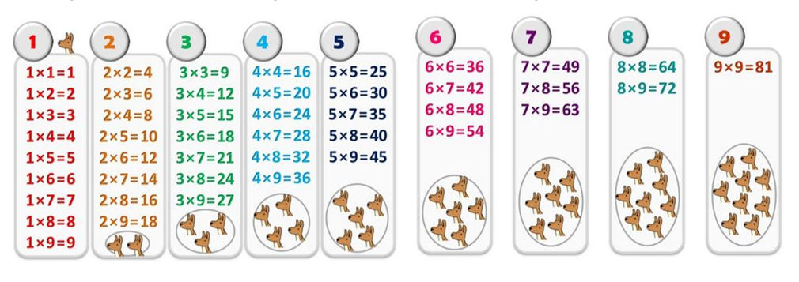

Division-
Key language which should be used: share, group, divide, divided by, half, ‘is equal to’ ‘is the same as’
Concrete | Pictorial |  | Abstract
6 shared between 2 (other concrete objects can also be used e.g. children and hoops, teddy bears, cakes and plates)  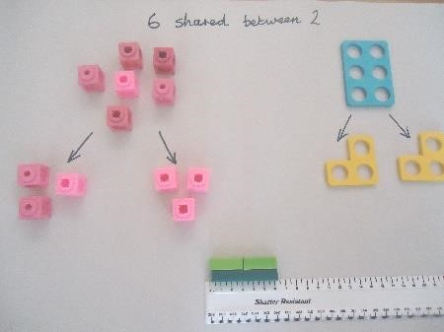 | 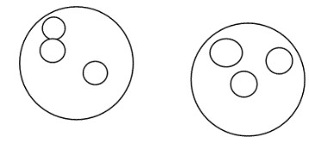  This can also be done in a bar so all 4 operations have a similar structure:  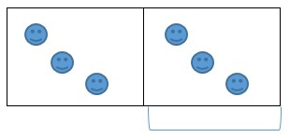 |  | 6 ÷ 2 = 3  What’s the calculation?
Understand division as repeated grouping and subtracting  6 ÷ 2  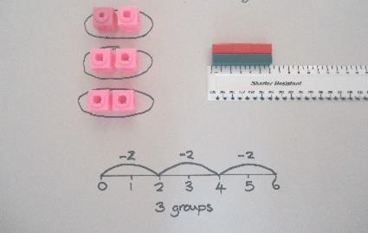 |  |  | Abstract number line  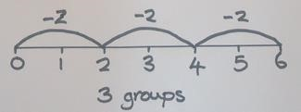
 | 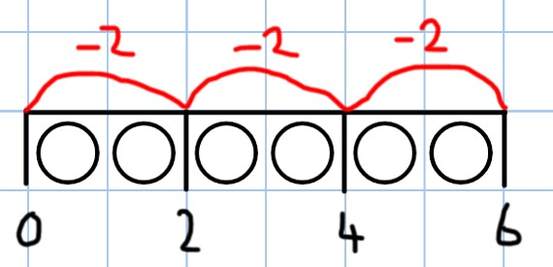
2d ÷ 1d with remainders  13 ÷ 4 – 3 remainder 1 | Children to have chance to represent the resources they use in a pictorial way e.g. see below: |  | 13 ÷ 4 – 3 remainder 1  Children to count their times tables facts in their heads

Use of lollipop sticks to form wholes  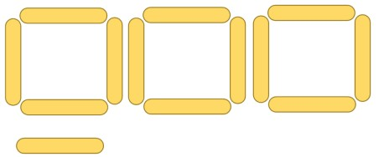  Use of Cuisenaire rods and rulers (using repeated subtraction)  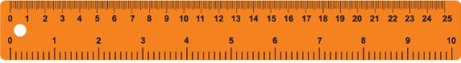 |  | 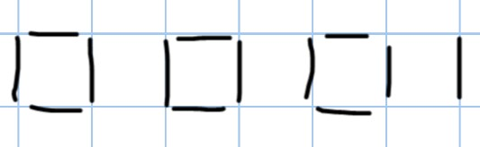 |  | 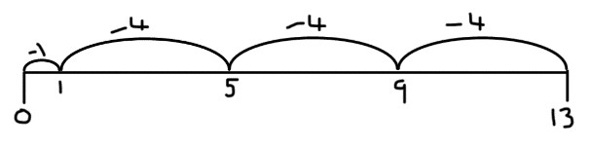
 |  | 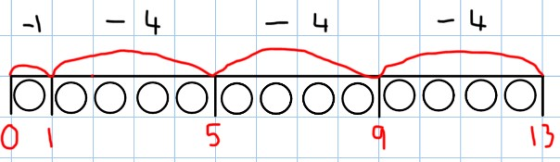
2d divided by 1d using base 10 (no  remainders) SHARING  48 ÷ 4 = 12  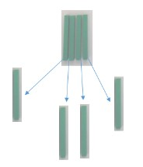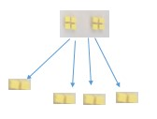 Start with the tens. |  | Children to represent the base 10 and sharing pictorially. |  | 48 ÷ 4  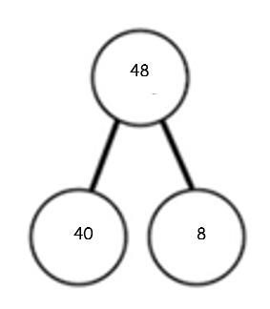 | 4 tens ÷ 4 = 1 ten  8 ones ÷ 4 = 2 ones  10 + 2 = 12
Sharing using place value counters.  42 ÷ 3= 14  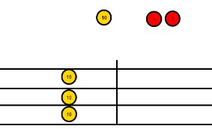  1. Make 42. Share the 4 tens between 3. Can we make an exchange with the extra 10? |  | 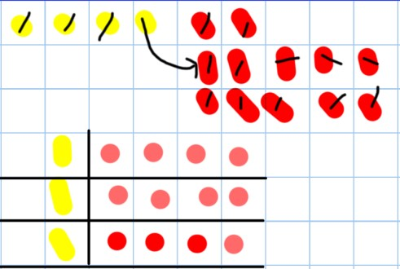 |  | 42 ÷ 3  42 = 30 + 12  30 ÷ 3 = 10  12 ÷ 3 = 4  10 + 4 = 14
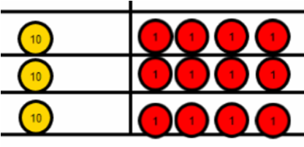 | Exchange the ten for  10 ones and share out  12 ones

Use of the formal method’ using grouping and counters. Key language for grouping- how many groups of X can we make with X hundreds’- this can also be done using sharing!  615 ÷ 5  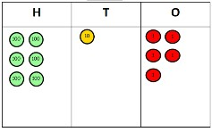  Step 1: make 615  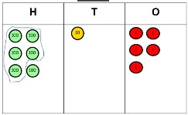  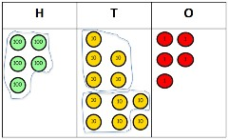  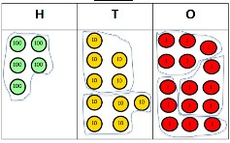  Step 2: Circle your groups of 5  Step 3: Exchange 1H for  10T and circle groups of  5  Step 4: exchange 1T for 10ones and circles groups of 5 |  | This can easily be represented pictorially, till the children no longer to do it.  It can also be done to decimal places if you have a remainder! |  | 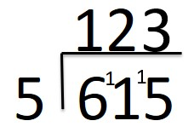
Varied Fluency, different ways to ask children to solve 615 ÷ 5:
Using the part whole model below, how can you divide 615 by 5 without using the ‘bus stop’ method?  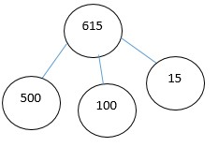 | I have £615 and share it equally between 5 bank accounts. How much will be in each account?  615 pupils need to be put into 5 groups. How many will be in each group? |  | 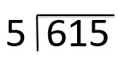  615 ÷ 5 =  = 615 ÷ 5  How many 5’s go into 615? |  | What’s the calculation? What’s the answer?  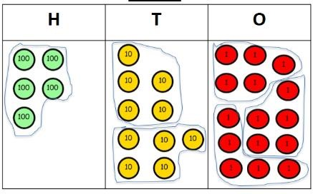

Long division
Concrete | Pictorial | Abstract
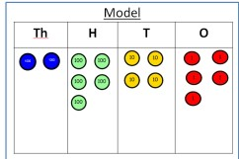  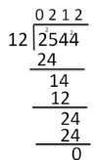  2544 ÷ 12  How many groups of 12 thousands do we have? None  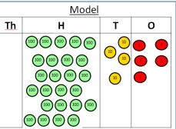  Exchange 2 thousand for 20 hundreds.  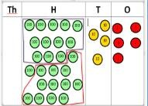  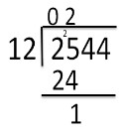  How many groups of  12 are in 25 hundreds? 2 groups.  Circle them. We have grouped 24 hundreds so can take them off and we are left with one.  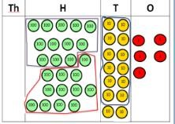  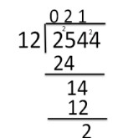  Exchange the one hundred for ten tens so now we have 14 tens. How many  groups of 12 are in 14? 1 remainder 2.  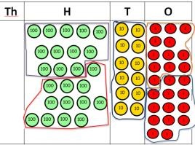  Exchange the two tens for twenty ones so now we have 24 ones. How many groups of 12 are in 24? 2 | Children to represent the counters, pictorially and record the subtractions beneath. | 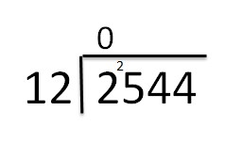  Step one- exchange 2 thousand for 20 hundreds so we now have 25 hundreds.  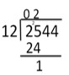  Step two- How many groups of 12 can I make with 25 hundreds? The 24 shows the hundreds we have grouped. The one is how many hundreds we have left.  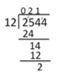  Exchange the one hundred for 10 tens. How many groups of 12 can I make with 14 tens?  The 14 shows how many tens I have, the 12 is how many I  grouped and the 2 is how many tens I have left.  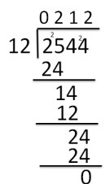  Exchange the 2 tens for 20 ones. The 24 is how many ones I have grouped and the 0 is what I have left.
Appendix: Specific year groups’ templates are also included to ensure clear progression.

