Curriculum  Area | Autumn 1 | Autumn 2 | Spring 1 | Spring 2 | Summer 1 | Summer 2
Project | Memory Box  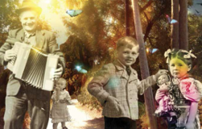 | Moon Zoom  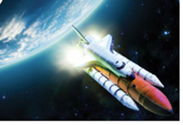 | Dinosaurs  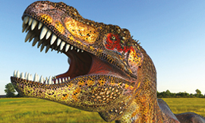 | Paws, Claws and Whiskers  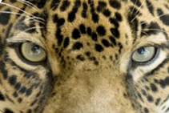 | Enchanted Wood  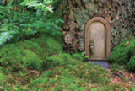 | Rio de Vida  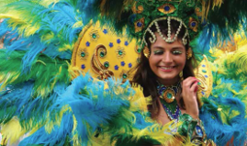
English | Recounts  Diary entries  Rhymes and Mnemonics  Descriptions  Information books | Posters  Character Profiles  Non-chronological reports  Adverts  Science fiction | Fact files  Poetry and riddles  Non-chronological reports  Narrative  Writing for different purposes | Recounts  Fables  Booklets and lists  Instructions  Nursery Rhymes and poems | Recounts  Information books and letters  Lists and instructions  Narratives | Poetry  Myths and Legends  Information texts  Postcards  Instructions
Mathematics | Place Value  Addition and subtraction  Shape  Place Value |  | Addition and Subtraction  Place Value  Multiplication  Measurement – length and height  Measurement – weight and volume |  | Number - Multiplication and division  Number - Fractions  Position and Direction  Measurement  Time
Science | Seasonal changes  Animals including Humans – parts and senses | Properties of Everyday materials  Working Scientifically | Plants and animals  Seasonal changes | Animals Including Humans  Working Scientifically  Seasonal Changes | Plants and animals  Identifying and classifying  Seasonal changes | Seasonal changes
Geography | Fieldwork in local area | Satellite images | Locating continents and oceans | Using and making maps  Describing physical features | Making maps | Locating countries and cities  Comparing areas of UK with Rio
History | Changes within living memory | Significant people – astronauts  changes within living memory | Learn about events beyond living memory that are significant nationally or globally
Computing | Entering text  Mouse control  Using tools on a paint program | Drawing software  Algorithms  Email  Photo stories | Programming a floor robot  Stop motion animation | Retrieving images  Photography  Using presentation software | Sending an email | Digital animations
Art | Drawing and painting  Collage  Family portraits | Models of the Solar System | Large and small scale modelling | Talking about art  Drawing collage  Model making  Sculpture  Animal masks and products | Working with natural materials  Drawing and painting | Carnival masks and headdresses  Collage
Design &  Technology | Making picnic food  Designing and making a memory box  Making celebration cards | Design and make space themed vehicles  Evaluating toys  Using mechanisms | Designing and making | Designing labels  Designing and making animal enclosures | Building structures  Making Party food | Carnival instruments  Flag making  Recipes
Music | Songs that help us to remember | Space sounds  Space themed songs | Percussion | Animal songs |  | Carnival music  Percussion instruments
MFL
(Taught as applicable)
PE  (Also see year group) | Future steps gross motor program | Future steps gross motor program | Future steps gross motor program | Future steps gross motor program | Future steps gross motor program | Future steps gross motor program
PSCHE | Caring for babies and toddlers  Sharing memories  Playing and working co-operatively  Feeling positive | Aspirations and goal setting |  | Caring for animals | Feeling positive  Looking after the environment | Special times  Understanding differences  What is fair and unfair
RE | Belonging - Christianity | Festivals- Beliefs and Practises – Christianity - Christmas | Belonging - Islam | Festivals- Beliefs and Practises – Christianity - Easter | Founders and Leaders - Islam | Belonging - Sikhism
Potential  Enhanced  Experience | Visit with baby | Alien spaceship crash landing | Dinosaur in classroom | Pet visit | Woodland walk | Carnival day

