Curriculum  Area | Autumn 1 | Autumn 2 | Spring 1 | Spring 2 | Summer 1 | Summer 2
Project | Mighty Metals | 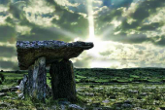  Tribal Tales | 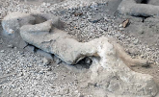  Tremors | 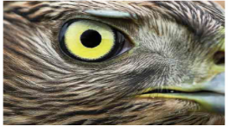  Predator | 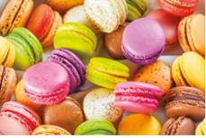  Scrumdiddlyumptious | 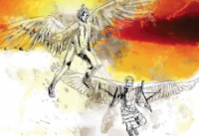  Gods and Mortals
English | Recounts  Play scripts  Novel – The Iron Man  Instructions  Poetry | Fairytales  Adventure Stories  Newspapers  Stories from the same author | Newspapers and Reports  Novel – The Firework Maker’s Daughter  Kennings | Stories set in an imaginary world  Performance Poetry  Non-chronological Reports  Letters | Class Novel – Charlie and the Chocolate Factory  Writing to Persuade/Advertisements  Humorous Poetry | Myths and Legends  Traditional Poetry  Writing to Explain  Biographies
Mathematics | Place Value and Number  Addition and Subtraction  Multiplication and Division |  | Multiplication and Division  Money  Statistics  Measure and Perimeter |  | Fractions  Time  Properties of Shape  Mass and Capacity
Science | Magnets and Materials | Light and Dark | Rocks | Animals including humans | Rocks | Plants
Geography |  | Human and physical features of geography | Map Skills – Locating continents, countries and oceans | Human and physical features of geography within the local area.  Animals and their Habitats | Fair trade  Distribution of Cocoa Beans | Climate Zones  Rivers  Greece and it’s surrounding islands
History |  | Study of Early Civilisation – Palaeolithic, Mesolithic and Neolithic era. | Pompeii  Krakatoa | The Evolution of animals | History of Bourneville  The Evolution of food and the changes in the British diet | Ancient Greece  Greece’s influence on civilisation
Computing | E-Safety  Using the internet  Creating and publishing | E-Safety  Using Excel  Multimedia | E-Safety  Collect analyse and evaluate data to present information. | E - safety  Using technology- Scratch- programming | E-Safety  Programme your own game  Programming – LOGO/WeDo Lego | E-Safety  Use a range of digital devices to design and control systems and programs.
Art | Model making - Robots | Cave Paintings | Clay volcano models | Predator Paintings/Sketching | Chocolate Collage
Design &  Technology | Designing Robot Models | Stonehenge Models  Making Stone Age Tools | Constructing Volcanoes using a variety of materials | Fabric Collages – Predators/Scavengers/Parasites | Packaging Design  Creating and making chocolate bars | Model Making – Greek Gods
Music | Using metal objects as instruments |  | Composition – Volcano noises |  | Food Orchestra – Food, Glorious Food
MFL | Numbers to 10 | Colours | Numbers to 20 | Animals | Days of the week  Months of the year | Instruments
PE | Tag Rugby | Tag Rugby | Cricket | Tennis | Track and Field | Track and Field
PSHE | Relationships |  | Well-Being |  | Living in the Wider World
RE | Hinduism | Nativity Story | Easter Story | Easter Story | Islam | Charity
Potential  Enhanced  Experience | Swimming |  | Swimming | Saltholme Nature Reserve  Kirkleatham Owls Centre | York Chocolate Story  Swimming

