Curriculum  Area | Autumn 1 | Autumn 2 | Spring 1 | Spring 2 | Summer 1 | Summer 2
Project | 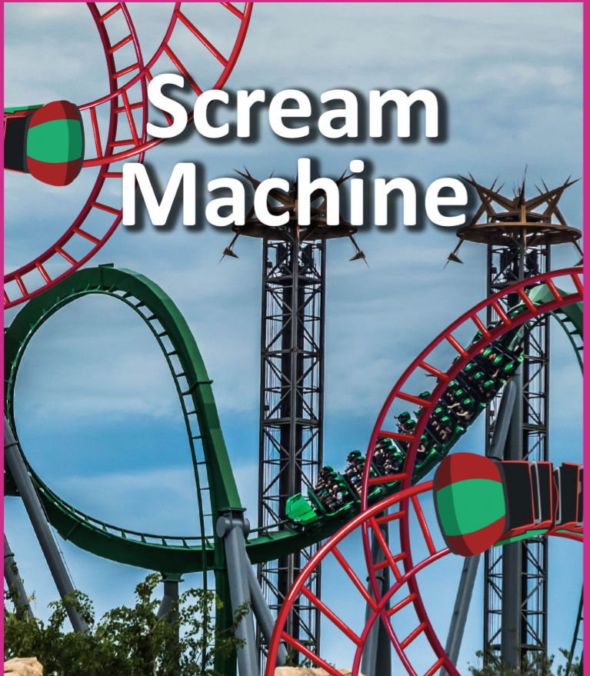 |  | 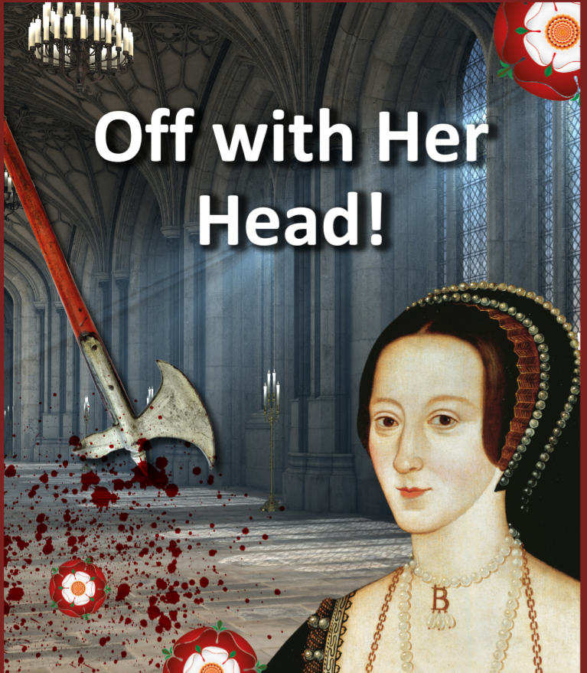 | 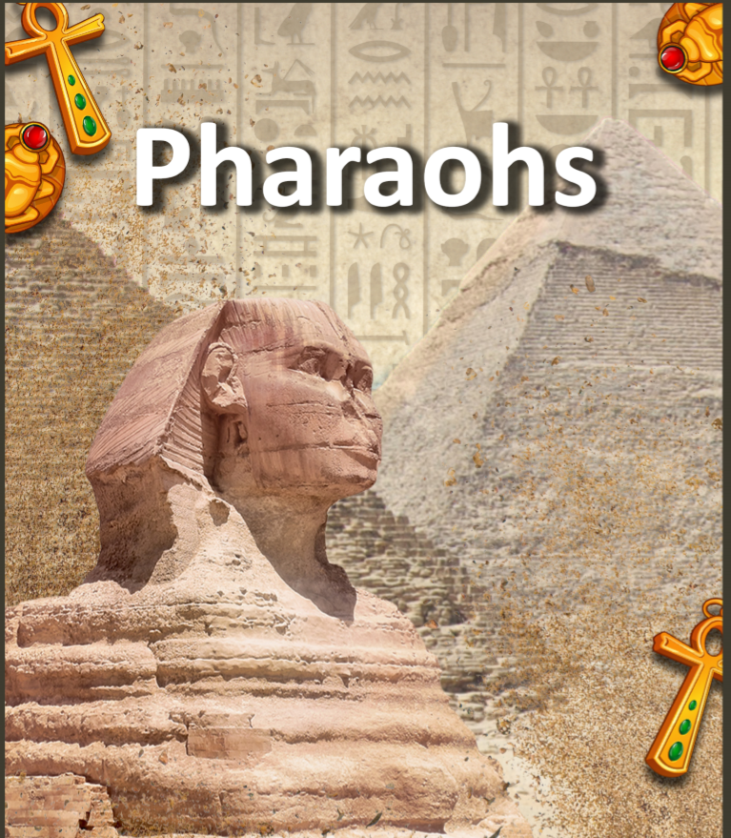 | 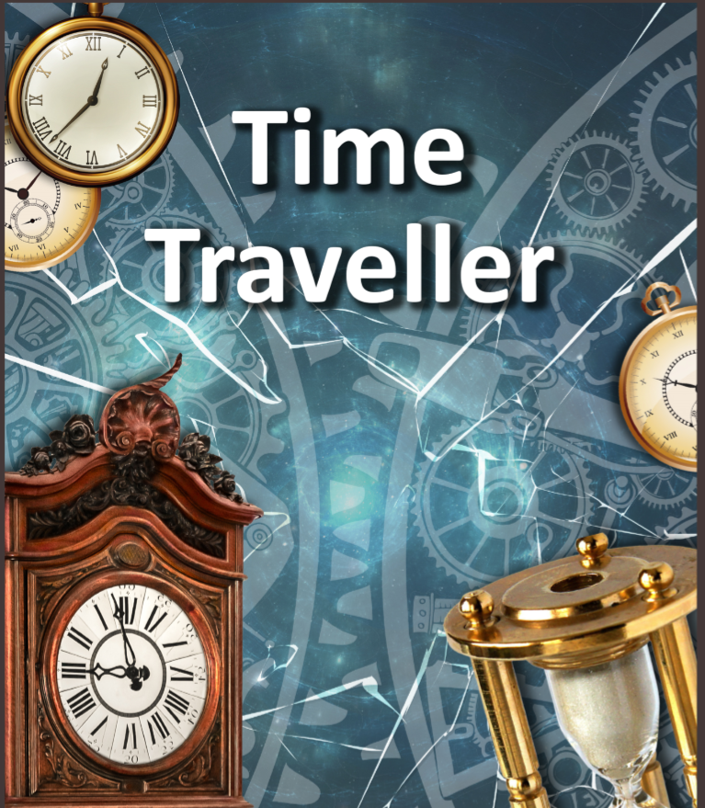 | 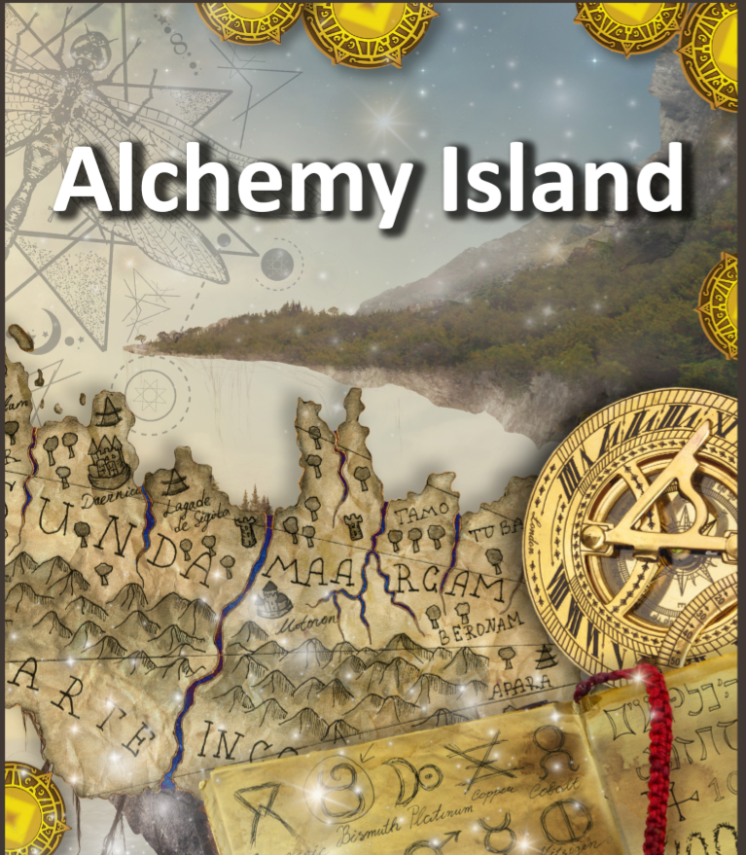
English | Shape Poetry  Short Narrative with dialogue  Persuasive Adverts  Explanation Texts | Mnemonics  Myths and Legends  Newspapers Reports  Science Fiction | Riddles  Biographies  Persuasive Letters  Newspaper Reports | Non Chronological Report  Fact Files  Mystery Stories  Play Scripts | Character Study  Flashbacks  Leaflets  Free Verse Poetry | Fantasy Narrative  Explanations  Fan Fiction  Soliloquies
Mathematics | Place Value  Addition and Subtraction  Multiplication and Division  Perimeter and Area |  | Multiplication and Division  Fractions  Decimals and Percentages |  | Decimals  Properties of Shape  Position and Direction  Converting Units of Measure
Science | Forces | Earth and Space | Properties and Changes of Materials | Properties and Changes of Materials | Animals including Humans | Living things and their habitats
Geography | Locational Knowledge: Counties and Cities of the United Kingdom | Human and Physical:  Physical Geography | Locational Knowledge:  Land use and changes over time | Human and Physical.  Place Knowledge: Egypt | Place Knowledge:  Local Area Study | Geographical Skills and Fieldwork:  Maps; 8 points of a compass and fieldwork.
History |  | Significant Individuals: Sir Isaac Newton  Neil Armstrong | The Tudor Dynasty | Ancient Civilisations: Ancient Egypt | Local History
Computing | Digital Photography  Digital Maps  Logical reasoning and algorithms  E-Safety | Programming: Stop Motion animation  E-Safety | Programming: Algorithms that combine a sequence of instructions  E-Safety | Programming: Algorithms that use 2 way selection and repetition  E-Safety | Digital portraits  Digital presentations  E-Safety | Programming: Debugging  E-Safety
Art | Photography and Image editing | Shadows and shading | Portraits and Sketching | Charcoal designs | Great Artists | Watercolour landscapes
Design &  Technology | Working Models  Food | Design functional products | Textiles | Sculpture  Cross Sectional and exploded diagrams  Model Pyramids and Tombs | Technological knowledge: Mechanical systems | Design, make and evaluate: A board game  Technological Knowledge: electrical systems.
Music | Fairground percussion | Performance | Staff and other musical notation | History of music | Composing lyrics | Listening to voices
MFL | Family members | Days of the week and months of the year | Zoo animals | Meals | Leisure / hobbies | Clothing
PE | Tag Rugby | Hi-5 Netball | Fitness | Tennis | Cricket | Athletics
PSCHE | Discussion and Debate |  | Rules and Consequences | Customs and Beliefs | Body Changes  Reflecting on spiritual, cultural and social issues  Setting personal targets  Feeling positive
RE | Places of Worship: Sikhism | Festivals, beliefs and practices:  How do we know about the Christmas Story? | Beliefs and Practices:  What food, drink and leisure are important in Islam and why? | Festivals, beliefs and practices:  How do betrayal and loyalty feature in the Easter story? | Worship in the Home:  Thematic compare and contrast Christianity, Islam and Sikhism | Worship in the Home:  Thematic compare and contrast Christianity, Islam and Sikhism
Potential  Enhanced  Experience | Visit to Theme Park | Planetarium Visit | Horrible Histories | Visit to Oriental Museum, Durham  Or  Great North Museum |  | Orienteering / Adventurous Outdoor Education  Visit to Holy Island

