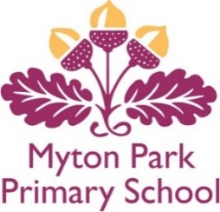

Together we Nurture, Inspire and Achieve
Blair Avenue Ingleby Barwick TS17 5BL; Telephone number 01642 754658
Email: mytonpark@mytonpark.org.uk Web: www.mytonpark.org.uk
Head Teacher – Mrs Janis Williams

6th October 21

Dear Parent/Carer

Your child has been chosen to represent Myton Park Primary School in the cluster Tag Rugby competition taking place on Tuesday 12th October 21 at Stockton Rugby Club. The children will leave school at 9.10am and return by 3.00pm.

Could your child please come to school in their PE kit and bring with them the following:

- Football boots if they have them as it may be muddy on the field;
- Spare clothes (i.e. joggers and a t-shirt) and a plastic bag to put any muddy clothes in;
- A packed lunch and water bottle;
- A warm coat in case it is cold.

Unfortunately, parents are unable to attend due to other schools being present.

Please complete and return the slip below.

Yours sincerely

J Williams
Mrs J Williams
Head Teacher

My child can attend the Tag Rugby competition on Tuesday 12th October 21.

My child normally has a paid/free school meal and I would like school to provide a packed lunch Y/N

Child’s name……………………………………………………………………………………

Signature of parent/carer……………………………………………………………………………………………………………………

